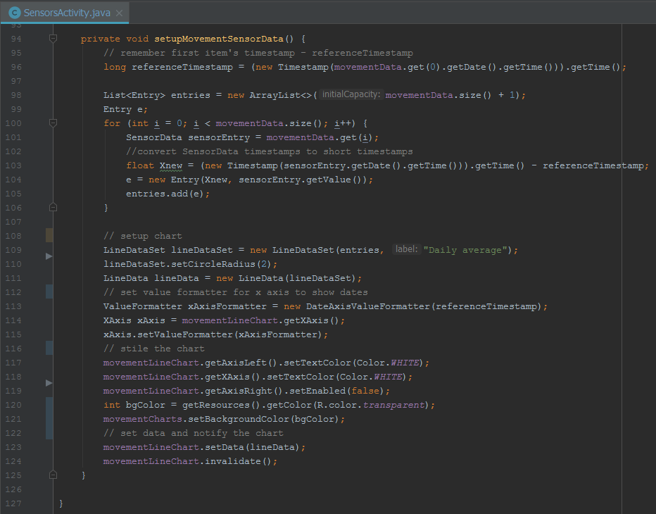

Since it was decided to use a line chart to visualize movement data, some changes were required in order to both customize the chart and show data correctly. In the line chart data is set using Entry class, that has two float values - x and y. In order to use date as an x value, the date was transformed to a timestamp and at the same time in order to reduce rendering time of the chart, the timestamp was converted to a smaller number using following conversion, which is applyed at line #103: newTimestamp = oldTimestamp - referenceTimestamp, where referenceTimestamp is a reference of the first date’s timestamp in the list. Later a custom ValueFormatter class (DateAxisValueFormatter) was created and set to the line chart in order to show dates instead of timestamps. DateAxisValueFormatter used the same convertion principle to convert short timestamps back to dates.

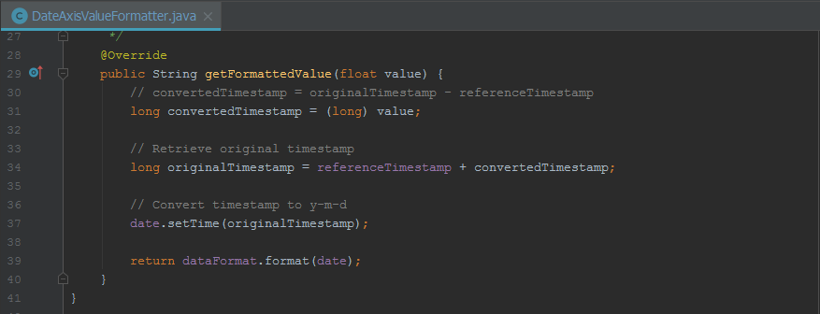

Once all the customization is done data is set to and the chart is notifyed.